**University Catalog Management System Version 2.0**

Mentor:

Tim Downey

Team Members:

Jose Astudillo

Christopher Sutton

Senior Project

CIS 4911 – U01

Masoud Sadjadi

September 4th, 2014

Table of Contents

1. Introduction 3

1.1 Problem Definition 3

1.2 Background 3

1.3 Definitions, Acronyms, and Abbreviations 4

1.3.1 Definitions 4

1.3.2 Acronyms and Abbreviations: 5

1.4 Overview of document 5

2. Feasibility Study 6

2.1 Description of Current System 6

2.2 Purpose of New System 6

2.3 User Requirements 7

2.4 Alternative Solutions 8

2.4.1 Description of Alternatives 8

2.4.2 Selection Criteria 9

2.4.3 Analysis of Alternatives 9

3. Project Plan 10

3.1 Project Organization 10

3.1.1 Hardware and Software Resources 10

3.1.2 Hardware and Software Resources 11

3.2 Identification of Tasks, Milestones and Deliverables 11

4. Appendix 12

4.1 Appendix A - Project schedule 12

4.2 Appendix B – Feasibility Matrix 13

4.3 Appendix C – Cost Matrix 14

4.4 Appendix D - Diary of Meetings 15

# Introduction

The University Catalog Management System is a system designed to easily create and manage curriculum information through a centralized user friendly web application. By centralizing this resource online for the SCIS department, the university will be able to scale this system across multiple degree granting units which could benefit many users at FIU.

## 1.1 Problem Definition

The University Catalog System is currently in a working state however there exists several possible enhancements that can be made in order to greatly increase the productivity of student and advisers who would use the system. Additional features such as flowchart visualization, enhanced user functionality, user interface enhancements, the ability to propose catalogs, and solid documentation are considered the top priorities associated with this project.

Currently catalogs are recorded through physical catalogs distributed to advisers and made available to students online as a PDF. However this is not a very dynamic approach to documenting data such as degree paths. By moving the catalogs online users will have increased search capabilities in finding information relevant to their majors. In addition to creating a good user experience for students, we also plan to focus on the advisers and how this system can benefit their everyday needs. Advisers sometimes need to quickly be able to switch between catalogs and search for various degrees and degree tracks. By creating an automatic algorithm for the creation of flowcharts, advisers will no longer have to rely on Microsoft Visio to design a degree path, instead they could directly manipulate courses via the flowchart visualization. Having a single platform that could archive previous and display current catalogs will provide a dynamic experience for all users.

## 1.2 Background

During the fall semester we plan to enhance the University Catalog System which is an application intended for students and advisers which would allow them to quickly view degree paths and a description about each course. The catalog system acts as a virtual encyclopedia for degrees at FIU enabling users to view previous year’s catalogs.

Currently the catalog system is displayed in the following format:

**Figure A: Degree Structure at FIU**

Within each degree program, information with regards to the number of credit hours, and a brief description is included. Each course is a part of some set within some degree track, and each course has a variety of information associated with it. Each course has a course name, a course identification which usually consists of a department acronym and a course number, number of credits, and a pre/co-requisites list.

## 1.3 Definitions, Acronyms, and Abbreviations

Below is a list of the definitions and acronyms that are used throughout this document in explaining the catalog system.

### 1.3.1 Definitions

|  |  |
| --- | --- |
| **Administrator** | Registered user with credentials. User has elevated privileges and can give access to other users. |
| **Adviser** | Registered user with credentials. Adviser acts as a point of contact for students when they have questions with regards to their courses. |
| **Catalog** | Catalog is a publication issued by the university each year that documents all degrees offered and their courses required for graduation. |
| **Degree** | Associates, bachelors, masters, or doctorate level of education. We are focusing on undergraduate. |
| **Degree Granting Department** | A general governing body at FIU that is authorized to offer classes that teach the topics required for graduation with an undergraduate degree. |
| **Electives** | Courses that are not required by the degree program but allow students to explore additional interests within their major. |
| **Lead Adviser** | Registered user with credentials. Users will acts as administrators. |
| **Lower Division** | Lower division classes refers to a student’s first 60 credit hours |
| **Major** | A major is a student’s desired focus of study. |
| **Required** | Classes that are required for a specific degree program. |
| **Sciences** | Classes that are a focus on the core science topics such as physics. |
| **Student** | A student at FIU who can access the catalog systems to explore different degree paths. |
| **Upper Division** | Upper division classes refers to classes that are in the core of degree program. Typically they are the last 60 credit hours. |
| **User** | Any general person who uses the system |

### 1.3.2 Acronyms and Abbreviations:

|  |  |
| --- | --- |
| **Admin** | Administrator |
| **CIS** | Computer and Information Sciences |
| **CSS** | Cascading Style Sheets |
| **DB** | Database |
| **DGU** | Degree Granting Unit |
| **FIU** | Florida International University |
| **GUI** | Graphical User Interface |
| **HTML** | Hypertext Markup Language |
| **JS** | JavaScript |
| **MVC** | Model View Controller |
| **PHP** | PHP: Hypertext Preprocessor |
| **SCIS** | School of Computer Information Sciences |
| **UCMS** | University Catalog Management System |
| **V2.0** | Version 2.0 |
| **Yii** | Yes it is Framework |

## 1.4 Overview of document

Throughout this document we will explore the requirements for this projects in addition to the technology we will be using to implement certain features. This document will act as the foundation for the enhancements of the existing project. Over the next chapter we will begin to explore the current system and the current system constraints that we are looking to provide solutions to.

# Feasibility Study

## 2.1 Description of Current System

The current catalog system has the infrastructure in place to record catalogs and a basic user interface for displaying such information. Three levels of user accounts have been created including students, advisers, admins however not all functionality desired by each user group has been implemented.

The front end is functional and helps provide a clear demonstration of what the system can be used for and how it can benefit advisers. The back end is partially implemented with a majority of the tables and relationships already defined. There are some gaps in the data which will need to be corrected to make this a system that can operate in a real university environment.

## 2.2 Purpose of New System

The new system will enhance usability with a focus on providing the necessary tools for our adviser user group. We also are looking at making key enhancements to the user interface in order to make the system more appealing to the everyday user.

Below is description of some of the tasks that would make the catalog system complete:

* Implement additional features for user accounts:
  + Student:
    - Enhance user interface.
  + Advisor:
    - Propose catalogs.
    - Change old catalogs.
    - Compare catalogs.
    - Alter flowchart visualization.
  + Admin:
    - Activate/Deactivate catalogs.
    - Approve/Reject proposed catalogs.
    - Make changes to active catalogs i.e. change the description of a course in a study program, codes.
    - Manages the authorization for different users.
    - Alter flowchart visualization.
* Implement or create an algorithm for the creation of flowcharts.
  + By creating a flowchart visualization we will be able to display degree information in a format that is clear and concise for both students and advisers.
* Provide the ability to contain older catalogs in the system to use as a point of reference.
  + Show and keep catalogs based on changes, i.e., if the latest catalog for computer science was approved in 2010, when selecting any other year in the range from 2010 to Present it must show the one approved in 2010.
  + Ability to compare two catalogs which will allow students and advisers to see how the course has changed and what degree path could be beneficial to the student.
* Allow the creation of new catalogs in the system.
  + Once a catalog is approved is must become the default for that academic year. Therefore pushing the older catalog into a history section.

## 2.3 User Requirements

* The system will maintain a secure connection to a database hosted directly at Florida International University. All database calls will be made through our framework Yii which will provide a secure environment to execute commands.
* Considering we are continuing this project from a group last year we are restricted to using their current framework so we will continue our development using Yii.
* The systems will have a graphical user interface that can accept input and retrieve data dynamically from the curriculum database based on criteria.
* Advisers will be able to update catalog information with their changes being reflected to the current system once approved.
* Advisers will be able to view a dynamic flowchart visualization for a certain degree track that will help them pin point a student’s progression.
* All user groups will be able to view a flowchart visualization. One that is editable and a default version.
* System will use the database as a reference in order to retrieve courses for any particular major.
* Flexibility to add new features to the current system.
* Ability to run across multiple web browser platforms and operating systems.

## 2.4 Alternative Solutions

When designing this system there is obviously many different ways to implement certain features that will accomplish the same task. Considering this we have started looking at alternative solutions in order to have a plan B if any of our current implementation methods proved not to be feasible.

### 2.4.1 Description of Alternatives

The database is a constant debate with this catalog system as the longtime goal of this project is for the system to provide versioning control across multiple catalog systems. Right now we are taking an approach to work with this long term goal of this system by looking to implement historical tables as we add new features to the system. The previous group has already laid the foundation for historical versioning, however it is not fully implemented as of yet.

Florida International University has two variety of flow charts that could be implemented in this catalog system. Below is two examples:

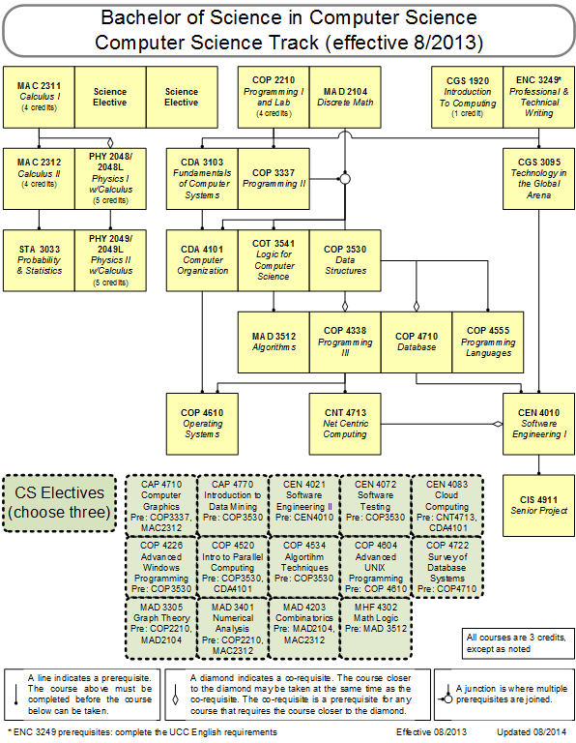 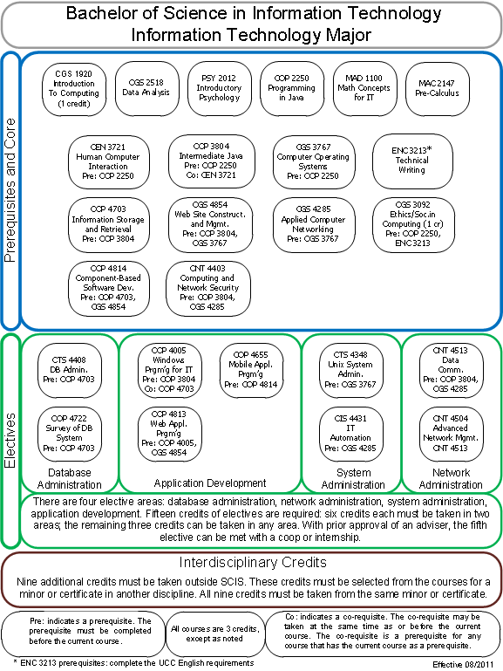

**Figure B: CS Flowchart Figure C: IT Flowchart**

The first flowchart (Figure B) is connected via lines and is often called an organization chart as courses are organized by their pre requisites. The second flowchart (Figure C) is grouped differently and is based on its groups and sets.

If we are unable to implement the organization flow chart, the second example of a flow chart can be implemented. The way this flow chart is set up complements the way our database is configured by describing each major through a track, group, set, and then a course list. If we were to implement the second example this can be done using dynamical object modeling using HTML, JS, and CSS. We can also implement functionality that will allow an adviser to dynamically change the structure of a flow chart by allowing them to move individual courses, sets, and groups.

### 2.4.2 Selection Criteria

Throughout the development of this project we will have to analyze each tradeoff when analyzing solutions to complex problems. Throughout this project we will focus on the following criteria:

* Data Redundancy
* Usability
* Expandability
* Maintainability
* Cost

### 2.4.3 Analysis of Alternatives

We will analyze all new features we implement in order to make sure they are feasible based on our selection criteria. By using our criteria as a base line we can ensure that we are creating the best system possible.

Each enhancement we make will need to consume data from our database. In order to ensure our database is efficient we need to minimize the scenario where redundant data is being placed into the database. To combat this the tables already set up provide versioning control and we have to ensure that with each database change, whether it be adding additional fields or tables, are able to accommodate multiple versions and promote a one too many structure. In order to create the flow chart dynamically new tables will have to be created in order for a major to have multiple flow charts based on catalog year and track version, this is why creating a one to many reference is critical because a major can have multiple tracks, a track can have multiple groups, a group can have multiple sets, and a set can have multiple courses.

By implementing the second flowchart visualization option based on a group layout usability can be increased by providing the ability to create additional features for the adviser. Considering it would be implemented using dynamic object modelling advisers would be able to manipulate course structures directly via the chart.

The second flow chart option is expandable because it can be used by every degree granting unit at FIU as each degree follows the same structure. The flow chart could act as the foundation for dynamically changing catalog structures.

It is maintainable as the code is generic and relies strictly on accurate data from the database. Each code segment will have a particular function for retrieving courses, formatting them, and laying them out in a particular order as dictated by the flow chart tables.

The cost of creating a dynamic flowchart visualization is high, however this is a feature that our mentor wanted specifically and believe would be a great asset to the system. The second flowchart visualization has a cheaper cost compared to the hierarchal version as the data needed can be modeled directly by creating additional tables and relationships in the database. Its set up is also more concise as we can focus on groups instead of specific requisites for each course.

Currently we are unable to find an API that we would be able to leverage in order to create an ER styled flow chart for degree tracks.

# Project Plan

In order to ensure a successful project we have created this initial plan with deadlines which we intend to stick by throughout the semester. This will allow us to see whether or not we are on track with our requirements.

## 3.1 Project Organization

This section details the roles of our group members and how we intend to tackle the various aspects of this project.

### 3.1.1 Hardware and Software Resources

The team working on this project consists of two members:

* **Jose Astudillo** : Manager, Developer, Tester, System Designer, GUI Designer
* **Christopher Sutton** : Manager, Developer, Tester, Database Manager

Manager, Developer, Tester, System Designer, GUI Designer

Jose Astudillo

Manager, Developer, Tester, Database Manager,

Christopher Sutton

**Figure D:** Team Project Organization

Figure D helps us understand better how the team is organized. Each team member will be the manager of the other. This means that every work done by a single team member will be revised by its manager. In addition, both members will work on the code, and testing. Each member also has different roles; for example, Jose Astudillo is the System Designer, and Christopher is the Database Manager. However, work will be revised by each other.

### 3.1.2 Hardware and Software Resources

The following technologies have been used to build the previous catalog version:

* Yii Framework
* PHP
* HTML/CSS
* MySQL
* Personal Laptops running Windows 7
* MyPhpAdmin Curriculum Database storing SCIS degree information.

While we acknowledge that these are already used throughout the project, we are not limiting our design or implementation to these languages and will be exploring possibilities for adding JS and JQuery.

## 3.2 Identification of Tasks, Milestones and Deliverables

|  |  |  |
| --- | --- | --- |
|  | Tasks | Task Dependencies |
| **1** | Review Current System |  |
| **2** | Problem Definition | 1 |
| **3** | Obtain High Level User Requirements | 2 |
| **4** | Identify Alternatives Solutions | 3 |
| **5** | Determine Solutions | 4 |
| **6** | Requirement Analysis and Elicitation | 2 |
|  | **Milestone: System Analysis and Implementation** |  |
| **7** | Implement Database Structural Changes | 6 |
| **8** | Populate Database with Data | 6, 7 |
| **9** | Modify System Architecture | 6 |
| **10** | Begin UI Design Modification for Forms | 8, 9 |
| **11** | Begin UI Design for Flowchart | 8, 9 |
| **12** | Implement Functions | 8, 10, 11 |
| **13** | Initial Testing | 8, 12 |
|  | **Milestone: Implemented System Functionality** |  |
| **14** | Finalize System Implementation | 13 |
| **15** | Functional Testing | 13 |
| **16** | Evaluate Test Results | 14, 15 |
| **17** | Complete Final Documentation and Presentation | 16 |
|  | **Milestone: System Complete** | 17 |

# Appendix

## 4.1 Appendix A - Project schedule

## 

## 4.2 Appendix B – Feasibility Matrix

The table below displays features based on their feasibility, and their value to the Catalog system:

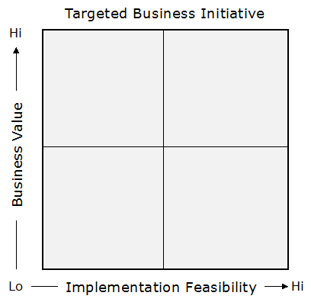

Admin Functionality

Create Catalogs

Flowchart Grouping

Table Exporting XML

User Account Set Up

User Interface Modifications

Flowchart Hierarchical

## 4.3 Appendix C – Cost Matrix

|  |  |  |
| --- | --- | --- |
| Item | Description | Cost |
| Human Resources | Team member working on the project during the entire development process. | $0.00 |
| Hardware Tools | Laptops | $0.00 |
| FIU Computers | $0.00 |
| Software Tools | Yii Framework | $0.00 |
| Netbeans | $0.00 |
| PHPAdmin | $0.00 |
| Total cost | | $0.00 |

## 4.4 Appendix D - Diary of Meetings

|  |  |
| --- | --- |
| Diary Entry 1 | |
| Date | Wednesday, September 3rd, 2014 |
| Location | ECS 341 |
| Start | 7:00 PM |
| End | 8:00 PM |
| Attendees | * Jose Astudillo * Christopher Sutton * Tim Downey |
| Agenda | * Review the existing system. * Get requirements for the project. |
| Summary | * Defined tools to be used for the development. * Explanation of the current system. * Brief definition of the functionalities to be implement for this version of the system. |
| Assigned Tasks | For both team members:   * Explore current system. * Get familiar with the tools to be used. |

|  |  |  |
| --- | --- | --- |
| Diary Entry 2 | | |
| Date | Sunday, September 7th, 2014 | |
| Location | JCCL Lab | |
| Start | 4:00 PM | |
| End | 7:00 PM | |
| Attendees | * Jose Astudillo * Christopher Sutton | |
| Agenda | * Start working on project plan. * Revise Feasibility Analysis document. * Revise SRD. * Work on Trello. | |
| Summary | * Trello was set up. * Worked on Feasibility document. * Worked on SRD. * Brief work on project plan. | |
| Assigned Tasks | Jose: work on SRD.  Christopher: work on feasibility document. | |
| Diary Entry 3 | |
| Date | Monday, September 8th, 2014 |
| Location | ECS 341 |
| Start | 7:00 PM |
| End | 8:00 PM |
| Attendees | * Jose Astudillo * Christopher Sutton * Tim Downey |
| Agenda | * Run v1.0 locally * Discuss functionalities to be implemented. |
| Summary | * Tried to run v1.0 locally. * Discussed about adding new user. Now, there will be 4 types of users: admin, student, advisors, and the regular visitor. * Christopher was assigned to work on administrator modules; additionally, he might complete some work on regular user. * Jose was assigned to work on advisor module mainly; however, he might work also in the student module. |
| Assigned Tasks | * Keep trying to get v1.0 to run locally. * Start writing use cases, and create sequence diagrams. |

|  |  |
| --- | --- |
| Diary Entry 4 | |
| Date | Wednesday, September 10th, 2014 |
| Location | ECS 341 |
| Start | 7:00 PM |
| End | 8:00 PM |
| Attendees | * Jose Astudillo * Christopher Sutton * Tim Downey |
| Agenda | * Run v1.0 of CMS locally. |
| Summary | * v1.0 running successfully. |
| Assigned Tasks | * Keep trying to get v1.0 to run locally. * Start writing use cases, and create sequence diagrams. * Familiarize ourselves with Yii framework. * Get familiar with the database. |

|  |  |
| --- | --- |
| Diary Entry 5 | |
| Date | Monday, September 15th, 2014 |
| Location | ECS 341 |
| Start | 6:30 PM |
| End | 7:30 PM |
| Attendees | * Jose Astudillo * Christopher Sutton * Tim Downey |
| Agenda | * Discuss system needs. |
| Summary | * Discussed what needs to be completed next. |
| Assigned Tasks | * Complete documents for use cases. * Make sequence diagrams from the use cases. * Create UI for the use cases to be implemented. |

|  |  |
| --- | --- |
| Diary Entry 6 | |
| Date | Monday, September 29th, 2014 |
| Location | ECS 341 |
| Start | 6:30 PM |
| End | 7:30 PM |
| Attendees | * Jose Astudillo * Tim Downey |
| Agenda | * Talked about create, edit, and propose prospective catalogs. |
| Summary | * Discussed about the flow for creating, editing, and proposing prospective catalogs. |
| Assigned Tasks | * Keep writing use cases, and creating diagrams. |

|  |  |
| --- | --- |
| Diary Entry 7 | |
| Date | Wednesday, October 1st, 2014 |
| Location | ECS 341 |
| Start | 6:30 PM |
| End | 8:00 PM |
| Attendees | * Tim Downey * Christopher Sutton |
| Agenda | * Discussion about Yii framework in detail. |
| Summary | * Talked about the controller and view set ups for degree unit, |
| Assigned Tasks | * Continue exploration of Yii framework and work on documentation. |
| Diary Entry 8 | |
| Date | Monday, October 6th, 2014 |
| Location | ECS 341 |
| Start | 6:30 PM |
| End | 7:30 PM |
| Attendees | * Jose Astudillo * Christopher Sutton * Tim Downey |
| Agenda | * Discuss changes to the database for implementing prospective catalogs. * Discuss changes for implementing new type of users. * Discuss algorithm for flow chart implementation. |
| Summary | * Discussed changes to the database for implementing prospective catalogs. * Discussed changes for implementing new types of users. * Permission granted by Tim Downey to work on the flowchart. |
| Assigned Tasks | Jose:   * Start creating views for the system. * Make changes to the database so that it can accept new users. * Make changes to the catalog table so that it can work with prospective catalogs.   Chris:   * Work on the flowchart algorithm. |

|  |  |
| --- | --- |
| Diary Entry 9 | |
| Date | Wednesday, October 8th, 2014 |
| Location | ECS 341 |
| Start | 6:30 PM |
| End | 8:00 PM |
| Attendees | * Tim Downey * Christopher Sutton |
| Agenda | * Show graphical API to use for the flow chart implementation |
| Summary | * Two API were show: Tree Map, and Org Chart. |
| Assigned Tasks | * Put required information into charts which can then be linked at a later date. |
| Diary Entry 10 | |
| Date | Friday, October 10th, 2014 |
| Location | ECS 341 |
| Start | 2:00 PM |
| End | 3:00 PM |
| Attendees | * Tim Downey * Christopher Sutton |
| Agenda | * Discussed table structure for flowchart visualization. |
| Summary | * Learned how to use tables created as a base point for linking. * Explored tables currently being used by panther soft. |
| Assigned Tasks | * Implement current table structure based of panther soft model. |

|  |  |
| --- | --- |
| Diary Entry 11 | |
| Date | Monday, October 13th, 2014 |
| Location | ECS 341 |
| Start | 6:30 PM |
| End | 8:30 |
| Attendees | * Jose Astudillo * Christopher Sutton * Tim Downey |
| Agenda | * Discuss presentation concerns. * Discussed topic suggested to automate students schedule for the next semester. * Discuss pop up implementation. |
| Summary | * The automation need was outside the project according to Tim Downey. * Decided to implement the flowchart using dynamic object modelling. |
| Assigned Tasks | Jose:   * Work on pop up.   Christopher:   * Start implementing flowchart algorithm. |

|  |  |
| --- | --- |
| Diary Entry 12 | |
| Date | Wednesday, October 15th, 2014 |
| Location | ECS 341 |
| Start | 6:30 PM |
| End | 7:30 PM |
| Attendees | * Jose Astudillo * Christopher Sutton * Tim Downey |
| Agenda | * Discuss Yii framework. * Discuss process for using DOM to create flow chart. |
| Summary | * Discussed problems using Yii active forms. * Discovered a large data gap; no pre/co requisites were listed in the databases. * Chris proposed a schema to implement which was accepted by Tim Downey. |
| Assigned Tasks | Jose:   * Keep working on pop up forms.   Christopher:   * Keep working on flow chart implementation. |

|  |  |
| --- | --- |
| Diary Entry 13 | |
| Date | Friday, October 17th, 2014 |
| Location | ECS 341 |
| Start | 2:00 PM |
| End | 3:00 PM |
| Attendees | * Tim Downey. * Christopher Sutton |
| Agenda | * Showed Tim Downey new tables for the flowchart visualization. |
| Summary | * Chris was provided with an example of a program using object modelling. |
| Assigned Tasks | * Ensure courses can be moved dynamically around the page. |

|  |  |
| --- | --- |
| Diary Entry 14 | |
| Date | Monday, October 20th , 2014 |
| Location | ECS 341 |
| Start | 6:30 PM |
| End | 8:30 PM |
| Attendees | * Jose Astudillo * Christopher Sutton * Tim Downey |
| Agenda | * Discuss about implementation of pop up form using Yii active form, or using JQuery. * Show current flexibility and layout of the dynamic flow chart form. |
| Summary | * Discussed methods that would allow saving the layout and its ability to be reloaded. * Discussed using JQuery. |
| Assigned Tasks | Jose:   * Keep working on forms.   Christopher:   * Look at methods for saving layout of groups, sets, and courses. |

|  |  |
| --- | --- |
| Diary Entry 15 | |
| Date | Wednesday, October 22nd, 2014 |
| Location | ECS 341 |
| Start | 6:30 PM |
| End | 8:30 PM |
| Attendees | * Jose Astudillo * Christopher Sutton * Tim Downey |
| Agenda | * Discuss problems in flowchart. |
| Summary | * Decided to use JQuery to pop up form for the different inputs of the prospective. * Fixed minor bug issues. * Showed current dynamic functionality. |
| Assigned Tasks | Jose:   * Keep working on pop up forms.   Christopher:   * Working on saving layout and implementing tables to accommodate the ability to save a positon. |

|  |  |
| --- | --- |
| Diary Entry 16 | |
| Date | Friday, October 24th, 2014 |
| Location | ECS 341 |
| Start | 2:00 PM |
| End | 3:00 PM |
| Attendees | * Tim Downey * Christopher Sutton |
| Agenda | * Discuss current flowchart implementation. |
| Summary | * Errors fixed in JS. * Left columns fixed. * Discussed on saving object location to database. |
| Assigned Tasks | * Work on creating a table that can link a degree track to a flowchart id. |

|  |  |
| --- | --- |
| Diary Entry 17 | |
| Date | Friday, October 31st, 2014 |
| Location | ESC 341 |
| Start | 2:00 PM |
| End | 3:00 PM |
| Attendees | * Tim Downey * Christopher Sutton |
| Agenda | * Discussed current progress. * Identified a solution to placing course information inside DIV’s. * Algorithm proposed for placing each course in the correct positon. |
| Summary | * Progress with the algorithm and overall structure of the database. |
| Assigned Tasks | * Implement table changes. * Implement hidden fields to record table information. |

|  |  |
| --- | --- |
| Diary Entry 18 | |
| Date | Monday, November 3rd, 2014 |
| Location | ESC 341 |
| Start | 6:30PM |
| End | 7:30 PM |
| Attendees | * Tim Downey * Christopher Sutton * Jose Astudillo |
| Agenda | * Demonstrated current progress. * Discuss documentation changes. * Elaborate on hidden field functionality. * Show new forms implemented. * Discuss how to implement editable forms. |
| Summary | * Demonstrated current functionality and discussed future changes to database and system. * Showed new forms with styling. |
| Assigned Tasks | * Continue working on flowchart visualization. * Work on editable forms. |

|  |  |
| --- | --- |
| Diary Entry 19 | |
| Date | Wednesday, November 5th, 2014 |
| Location | ECS 341 |
| Start | 6:30 PM |
| End | 8:00 PM |
| Attendees | * Christopher Sutton * Tim Downey |
| Agenda | * Discuss final layout for flowchart visualization. * Discussed database. * Hidden fields functioning. |
| Summary | * Layout of the visualization agreed upon. * Database changes need to be made. |
| Assigned Tasks | Christopher:   * Add Flow_Group and Flow_Set tables. * Create a controller for the FlowChart * Create a model for Flow_Course. |

|  |  |
| --- | --- |
| Diary Entry 20 | |
| Date | Friday, November 7th, 2014 |
| Location | ESC 341 |
| Start | 2:00 PM |
| End | 3:00 PM |
| Attendees | * Tim Downey * Christopher Sutton |
| Agenda | * Discussed models and controllers in Yii. * Determined the best was to interpret Post Data from the flowchart. * Worked on submitting values to the database. * Created views, forms, controllers, models, and links for the Flow_Course relation. * Discussed the need for data parsing when dealing with hidden values. * Overall developed a greater understanding of the Yii Framework. |
| Summary | * Significant progress made with database and flowchart visualization. * Set views completed. |
| Assigned Tasks | * Continue finishing implementation. |
| Diary Entry 21 | |
| Date | Monday, November 10th, 2014 |
| Location | ESC 341 |
| Start | 6:30 PM |
| End | 8:00 PM |
| Attendees | * Tim Downey * Christopher Sutton * Jose Astudillo |
| Agenda | * Demonstrate current functionality with a focus on the core building block of a set that contains courses. * Dynamic modelling demonstration to allow users to interact with the model visualization. * Show editable forms for all necessary inputs in the CMS. * Discuss the creation, submission, acceptance, and rejection of prospective catalogs. |
| Summary | * Set view working dynamically and acts as building block for the entire flowchart visualization. * Demonstrated editable forms. |
| Assigned Tasks | * In order to continue building upon the Set view the database tables will have to be modified in order to store multiple flowcharts for a signal set, group, or track. Schema proposed. |
| Diary Entry 22 | |
| Date | Wednesday, November 12th, 2014 |
| Location | ESC 341 |
| Start | 6:30 PM |
| End | 8:00 PM |
| Attendees | * Tim Downey * Christopher Sutton |
| Agenda | * Demonstrate current functionality. * Demonstrate finalized database for the flowchart. * Initiated plan for implementing Group and Track charts. * Discussed possibility for being able to tie a chart to a specific user (May be out of scope for this cycle) |
| Summary | * Database finalized. * Group and Track plans initialized. |
| Assigned Tasks | * Implement Track and Group charts. |

|  |  |
| --- | --- |
| Diary Entry 23 | |
| Date | Monday, November 24th, 2014 |
| Location | ESC 341 |
| Start | 6:30 PM |
| End | 9:00 PM |
| Attendees | * Tim Downey * Christopher Sutton * Jose Astudillo |
| Agenda | * Demonstrated finished flowchart functionality. * Discussed a few changes to the design and layout which can be manipulated in CSS. * Discussed refining algorithm to take in to account the number of pre-requisites for each course for a default view chart. * Demonstrated finished prospective catalog process. |
| Summary | * Flowchart visualization completed. * Design needs modification. * Prospective catalog process successfully completed |
| Assigned Tasks | * Work on flowchart design. * Work on documentation. |

|  |  |  |  |
| --- | --- | --- | --- |
| Diary Entry 24 | | | |
| Date | | Monday, December 1st, 2014 | |
| Location | | ESC 341 | |
| Start | | 6:30 PM | |
| End | | 9:00 PM | |
| Attendees | | * Tim Downey * Christopher Sutton * Jose Astudillo | |
| Agenda | | * Discuss final points for UCMSv2. * How to better pitch problems of the project. | |
| Summary | | * Clear understanding the last points for client. * Found a better way to pitch problems. | |
| Assigned Tasks | | * Finish documents. * Work on videos. * Work on posters. | |
| Diary Entry 25 | | |
| Date | Sunday, December 7th, 2014 | |
| Location | ESC 341 | |
| Start | 1:00 PM | |
| End | 5:00 PM | |
| Attendees | * Christopher Sutton * Jose Astudillo | |
| Agenda | * Record videos. | |
| Summary | * Videos recorded. | |
| Assigned Tasks | * Finish documents. | |